**Academic Achievements of ECE Department, 2023-24**

* Chip to startup (C2S) project entitled “Design and development of System-on-Chip for Single-Lead Wearable Electrocardiogram (ECG) for medical devices” under the Ministry of Electronics & Information Technology, R&D in Electronics Group (Microelectronics Development Division) has been sanctioned as per office order no: EE-9/2/2021-R&D-E, dated:19-05-2023 with amount Rs. 3,63,32,000/- (grant of Rs. 90,88,000/- to SLIET Longowal) to Dr. J S Ubhi (PI) and Dr. Surinder Singh (Co-PI).
* Project titled “ Design and Fabrication of Self-Multiplexing Circularly Polarized Antenna using Substrate Integrated Waveguide Technology for 5G and IoT Wireless System” under SERB has been sanctioned with Rs. 5,00,000.00 on dated 25/05/2023 to Dr. Kundan Kumar.
* 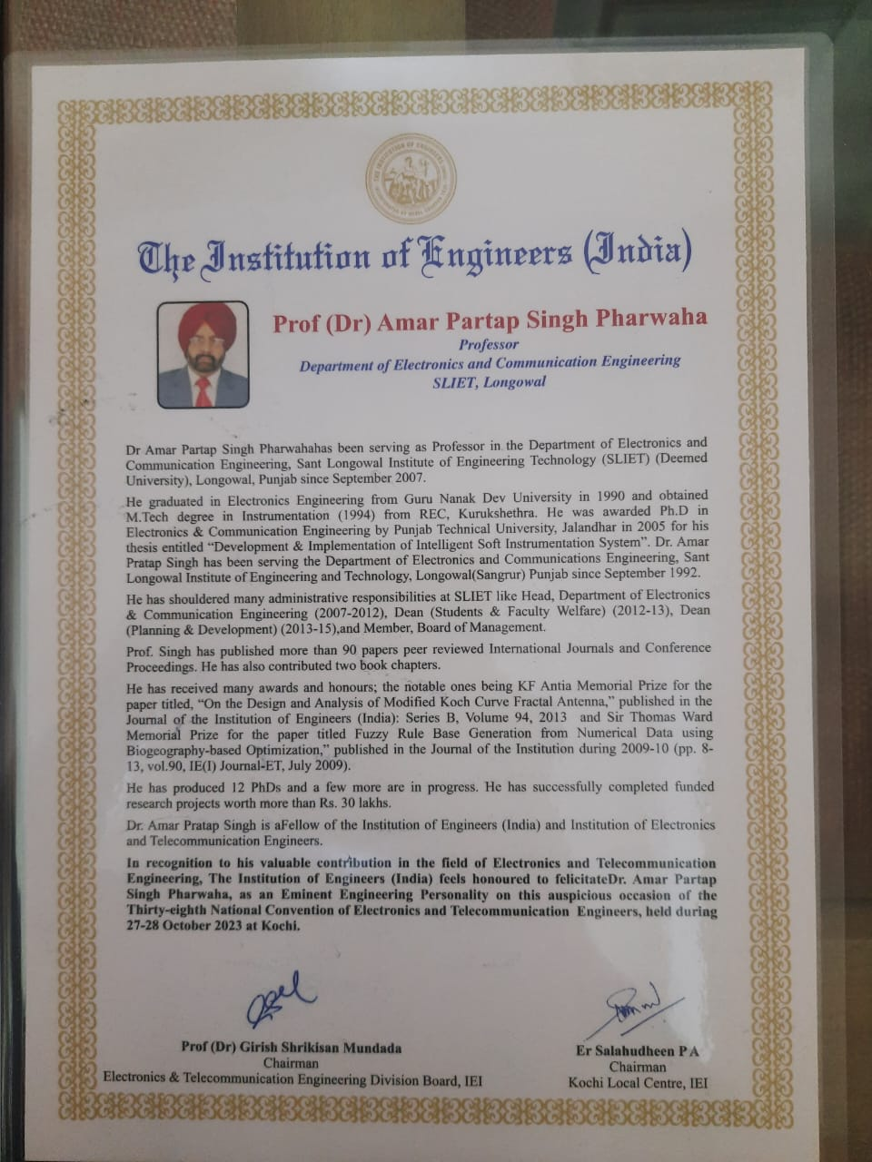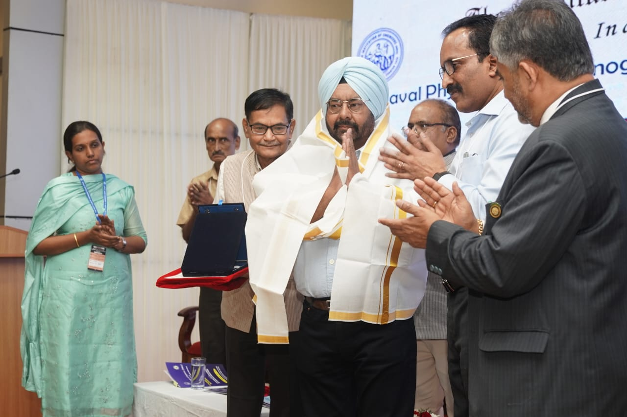Prof. Amar Partap Singh Pharwaha was felicitated by the Institution of Engineers (India), as an Eminent Engineering Personality on the auspicious occasion of the 38th National Convention of Electronics and Telecommunication Engineering, held during 27-28 October 2023 at Kochi.
* Department of Electronics & Communication Engineering has organized an Industrial trip to BSNL, Sangrur on 6th November 2023 for students of GEC-22.
* The proposal submitted by Prof. J S Ubhi has been selected for Visvesvaraya Ph.D. Scheme for Electronics and IT by the Ministry of Electronics and Information Technology (Meity), Government of India **for the successive second year** during the academic session 2023-24, to receive a grant of Rs. 1,37,21,600/- (Rs. One Crore Thirty-Seven Lakh Twenty-One Thousand and Six Hundred only) for 4 Full Time Ph.D. candidates fellowship and infrastructure development. The objective of the scheme is to enhance the number of PhDs in Electronics System Design and Manufacturing (ESDM) and IT/IT enabled Services (IT/ITES) sectors in the country. MeitY has also announced the Semicon India Policy to increase India's share in global semiconductor market wherein India Semiconductor Mission (ISM) is taking rapid strides to generate talent in semiconductor design & fabrication area in India for the world. Aligned with the goal of Semicon India Policy/ ISM and Chips to Start-up (C2S) Programme, Visvesvaraya PhD Scheme also aims to provide dedicated thrust to generate semiconductor talent in the country at PhD level.
* Prof. J S Ubhi delivered a Keynote address during “World Standards’ Day” on 20th October 2023 organized by Punjab and Chandigarh State Centre, Institution of Engineers (India), Chandigarh.

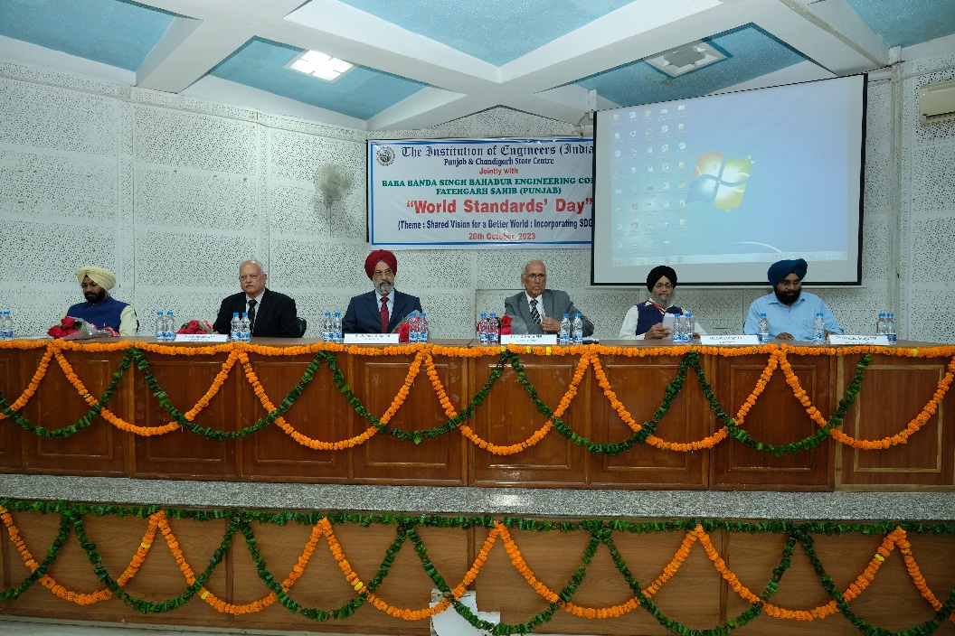

* Department of Electronics and Communication Engineering conducted a 2-days face-to-face training program on “Design and Development of Terahertz Self-Multiplex Antennas Using Substrate Integrated Waveguide for 6G Wireless Communication System’ during 29–30, September 2023 under SERB-SRG Sanctioned project. The inauguration of the program was held on September 29, 2023 with the esteemed presence of Dr. Mani Kant Paswan, Director SLIET, who graced the occasion as a Chief Guest. Dr. Surinder Singh,Dean(R&C) and Dr. Kamlesh Prasad, Dean(FSW) also graced the occasion as a guest of honour. Dr. Ajay pal Singh, Chairman and HOD(ECE) graced the event. The program is being led by Dr. Kundan Kumar, Coordinator and PI of Project, and Resource Persons Dr. Anupma Marwaha. Other Faculty and Staff members of the department are present during inaugural to grace the event. Over 26 participants from SLIET have attained the training program.

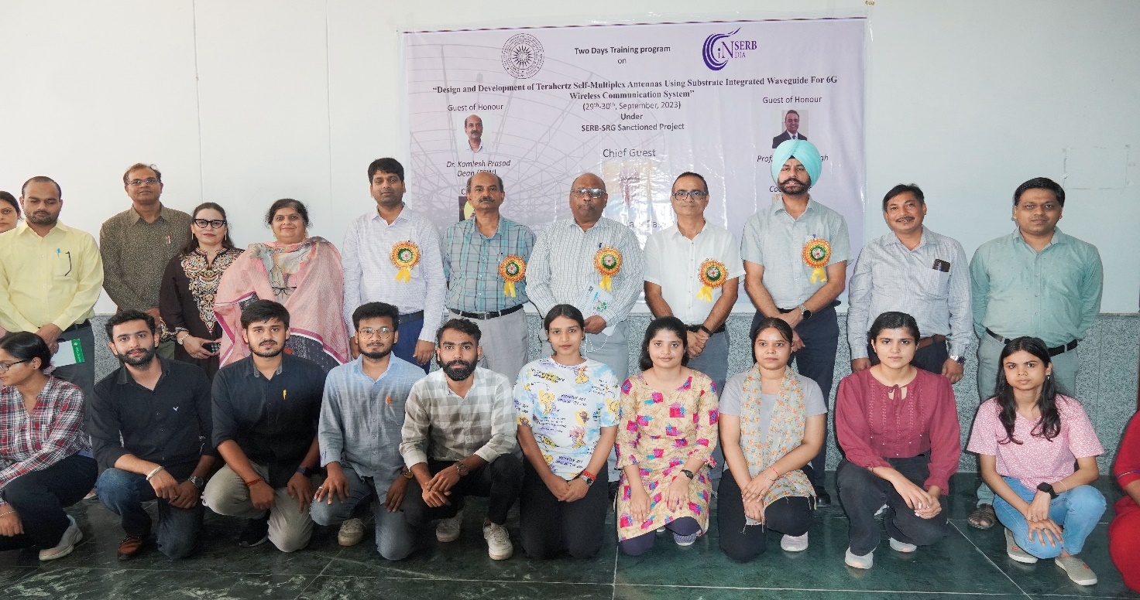

* Project titled “ Design and Development of advanced sensors based on fusion of microstrip patch and surface acoustic wave for soil analysis towards precision agriculture” under DST, New Delhi (DST-DAAD) has been sanctioned with Rs. 9,35,000.00 on dated 05/12/2023 to Dr. Surinder Singh.
* One week Short Term Training Program (STTP) on “Technology for Agriculture” was organized in hybrid mode by the Department of Electronics and Communication Engineering, SLIET Longowal from 5th February 2024 to 9th February 2024. The coordinators of this STTP were Dr. Sarbjeet Singh and Prof. Dilip Kumar. Prof Ajay Pal Singh, Head of the Department (ECE) was the chairman of this STTP.

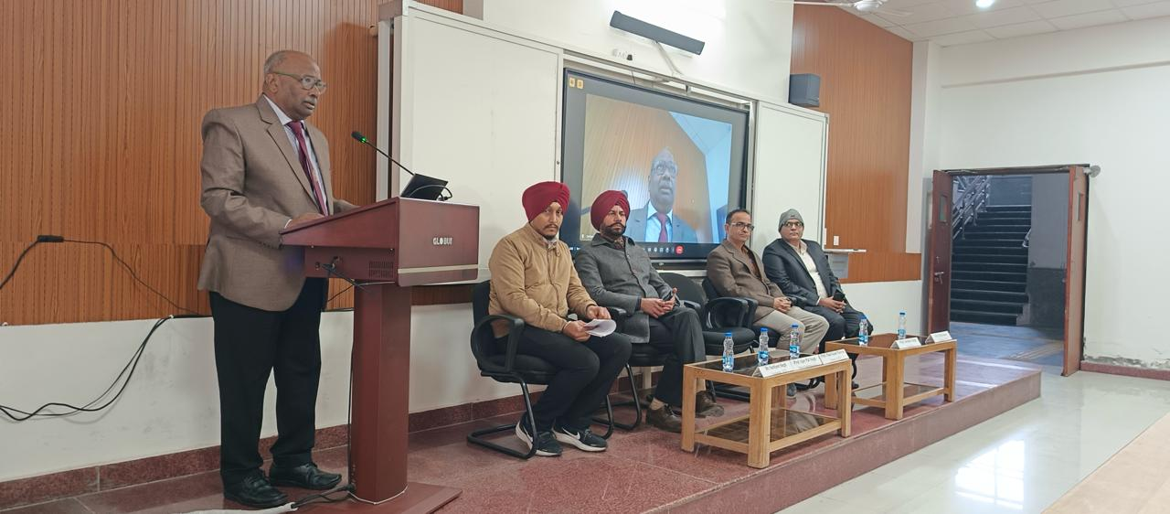

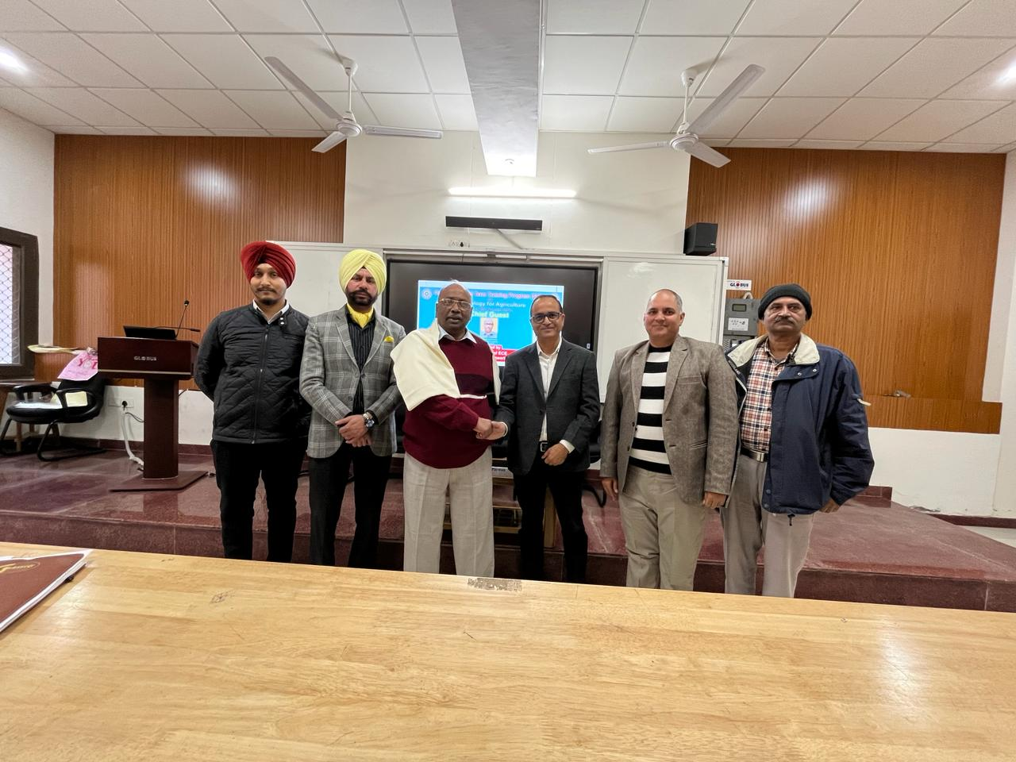

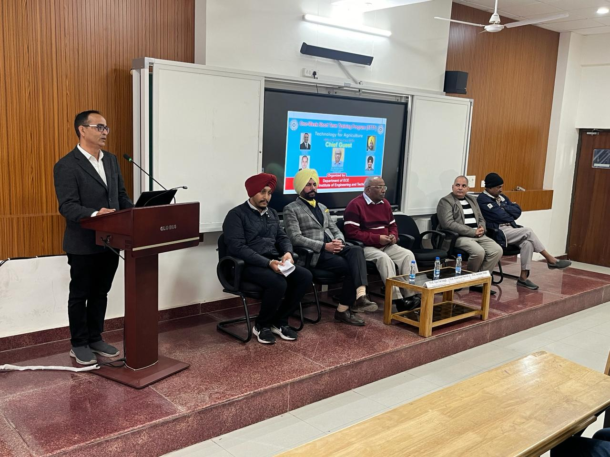

* Dr.-Ing. Olfa Kanoun, Professor and Chair of Measurement and Sensor Technology at Chemnitz University of Technology, Germany, delivered an insightful guest lecture on March 1, 2024, at 10:30 AM in Room No. EE-105, SLIET Longowal. The lecture focused on the "Prospects of Smart Sensors" and their potential in advancing farming practices, particularly in the Punjab region of India. Prof. Kanoun provided deep insights into how smart sensor technology can be leveraged to increase farming productivity while preserving the soil's chemical composition. Attendees, including Prof. Manikant Paswan, Director SLIET, Prof. Surinder Singh, Dean (R&C), faculty, staff members, PG Scholars, and Ph.D. Scholars, actively engaged in the lecture. The lecture, sponsored by the DST-DAAD joint program, aimed to facilitate research knowledge exchange. Prof. Kanoun's visit, along with her research scholar, Mr. Dhivakar Rajendran, was sponsored by the governments of India and Germany under the DST-DAAD program.

The photographs during a guest lecture:



